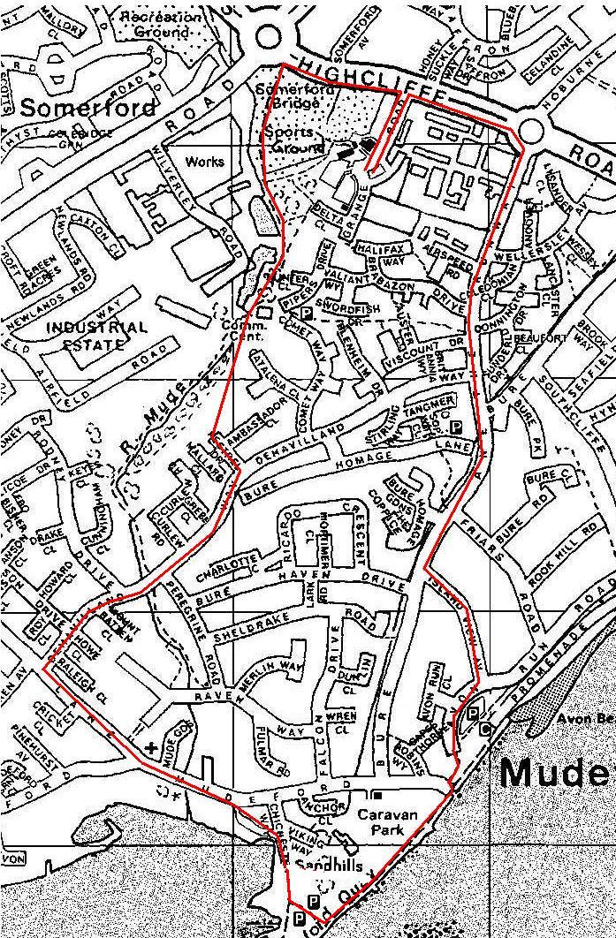

The “normal” direction is anticlockwise and is run in April, June, July and September.

The “reverse” direction is clockwise and is run in May and August.

Monthly Race, Normal (Summer) Route:
1. Head north on Grange Rd and at the dual-carriageway turn left following the path to the left and into Mudeford Woods.
2. At the community centre leave the path and run diagonally across the grass field and past the brown barrier into Kestrel drive.
3. At the end of Kestrel drive turn right into De Havilland Way
4. At the end turn left onto Mudeford Lane
5. At the end turn left onto Mudeford and cross when it is safe to do so
6. Cross the road by the shops, and fork right down the road with no-entry signs
7. Follow the road to the main car park (do not use the footpath to the playground on the left near the seafront) and turn left past the barrier along the prom
8. When you go through the next barrier, turn left across the car park entrance and turn right up the footpath immediately after the car park entrance
9. Turn left to skirt the sunken car-park and turn left into Island View Avenue
10. At the end turn right onto The Runway
11. At the roundabout turn left onto Highcliffe Road (dual carriageway)
12. Turn left into Grange Road and finish.

Monthly Race, Reverse (Summer) Route:
1. Head north on Grange Rd and at the dual-carriageway turn right.
2. At the roundabout turn right onto The Runway.
3. Take the 5th left into Island View Avenue
4. At the end turn right and skirt the sunken car-park, then drop down the footpath to the promenade and head west towards Mudeford Quay.
5. At the car-park turn right (do not use the footpath to the playground on the right near the seafront), instead follow the road to exit Mudeford Quay.
6. After the bridge take the left fork and at the end turn left onto Mudeford, then 3rd right onto Mudeford Lane.
7. Take the 1st right onto De Havilland Way and then the 4th left into Kestrel drive.
8. At the end of Kestrel drive run past the brown barrier into the field.
9. Run diagonally across the field to join the path that passes to the left of the community centre.
10. Follow the path through Mudeford Woods and turn right as you exit the woods following the path.
11. Turn right into Grange Road and finish.

Distance markers in normal direction:
½ Mile On track by very large tree in open space on right
1 Mile 3 yards past letter box, by footpath sign
1 ½ Mile At bus stop in Mudeford Road
2 Mile At end of caravan park, 4 yards before wall rises
2 ½ Mile Junction main road and Bure Homage Gardens (by large tree on right)
3 Mile Far end of lay-by at East Gate

Distance markers in reverse direction:
½ Mile 8 yards after 2nd tree after Airspeed Road Cross Over at Bure Homage Gardens
1 Mile No. 22 Island View Ave right hand gate post
1 ½ Mile Dog waste bin at the end of the promenade - 5 yds before 5 Bar Gate
2 Mile Bus stop road marking on right hand side of Mudeford Lane outside No.134
2 ½ Mile 3rd tree R H Side of Football pitch after going thro' gate
3 Mile 1st drain cover after leaving path from wooded path (Wessex Water metal gates) & 6 yds after crossing wooded bridge from path from wooded path

