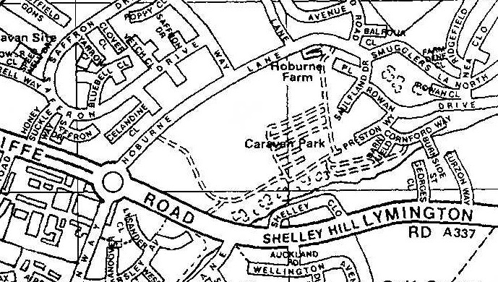
Start
Half-Way

READ THIS OUT TO THE RUNNERS BEFORE THE START

Note the route markings on the map are only a rough guide. Read and obey the following instructions:-

Staggered start at the 10k finishing point, based on roughly half the monthly race handicap.

Turn left at the roundabout and up Hoburne Lane, crossing to the other side as you go.

Turn right at the shops, then first left, first right, first left, first right and across the footbridge on your left to St Georges Close. Go up righthand side of St Georges Close to Lymington Road and then turn right.

Go to, and turn into, Shelley Close.

Follow the pavement that you are on all the way round Shelley Close (do not cut across to the other side of the road) and then continue down Lymington Road.

Turn right at the roundabout and the timer will be in the lay-by.

2 minutes after the last arrival, there will be a mass start and you run the whole thing again, but in reverse. NOTE that the Shelley Close rule still applies.

