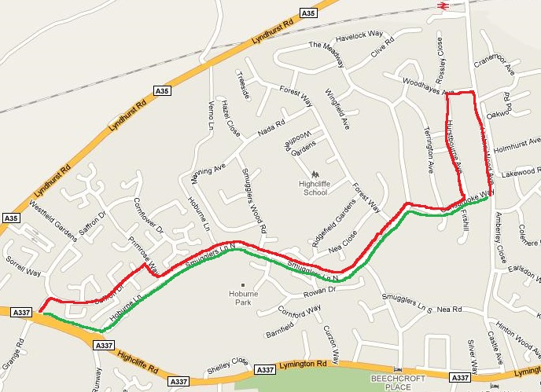
Runners will be paired up: Fastest with Slowest, 2nd Fastest with 2nd Slowest etc. The route is circular. The runners in each pair set off together but run opposite ways round the loop. When the pair meet, the runners turn around and head back the way they came.
Faster Runner (red route)
Head into the estate and turn right along Saffron Drive. At the end of the road turn right and then left along Hoburne Lane.
Keep running until you reach Hurstbourne Avenue (the last turning before the end of the road).
Turn left into Hurstbourne Avenue then keep turning right until:
- If you meet your partner before you get back to the entrance to Hurstbourne Avenue, you both turn round and retrace your route to the start.
- If you get back to the entrance to Hurstbourne Avenue before meeting your partner you will need to run past Hurstbourne until you meet, and then you both turn round
Slower Runner (green route)
Run along the dual-carriageway to the roundabout and turn left into Hoburne Lane.
Follow the road all the way to the end. If you have not met your partner keep turning left until you do.
Keep running until you meet your partner, then you both turn round and retrace your route to the start.

