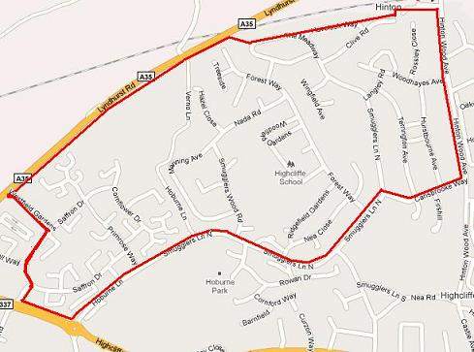
Runner 1

Head up the left-hand branch of Saffron Drive and turn left into Westfield Gardens. Turn right at the end up the A35. After crossing Verno Lane ignore the first path. Ignore the next track (with a green barrier across), and take the next path with a bollard at the entrance. (There should be a brick wall on the opposite side of the road where the railway goes under – if you reach the railway on your side of the road you have gone too far). Go down the steps to the road and turn left. Stay on the left hand footpath and keep running straight ahead. When you get to the dead-end follow the path to the main road and turn right (i.e. the 10k run in reverse). Then take the second right into Carisbrooke Way and keep running.

Runner 2
Head along the dual carriageway, turn left up Hoburne Lane. Stay on the left-hand path. Keep running ahead. When the road bends sharp right, follow it round – don’t turn left. When you reach the very end turn left. Turn left on the path just before the station and when you reach Clive Road stay to the right and run straight ahead.

