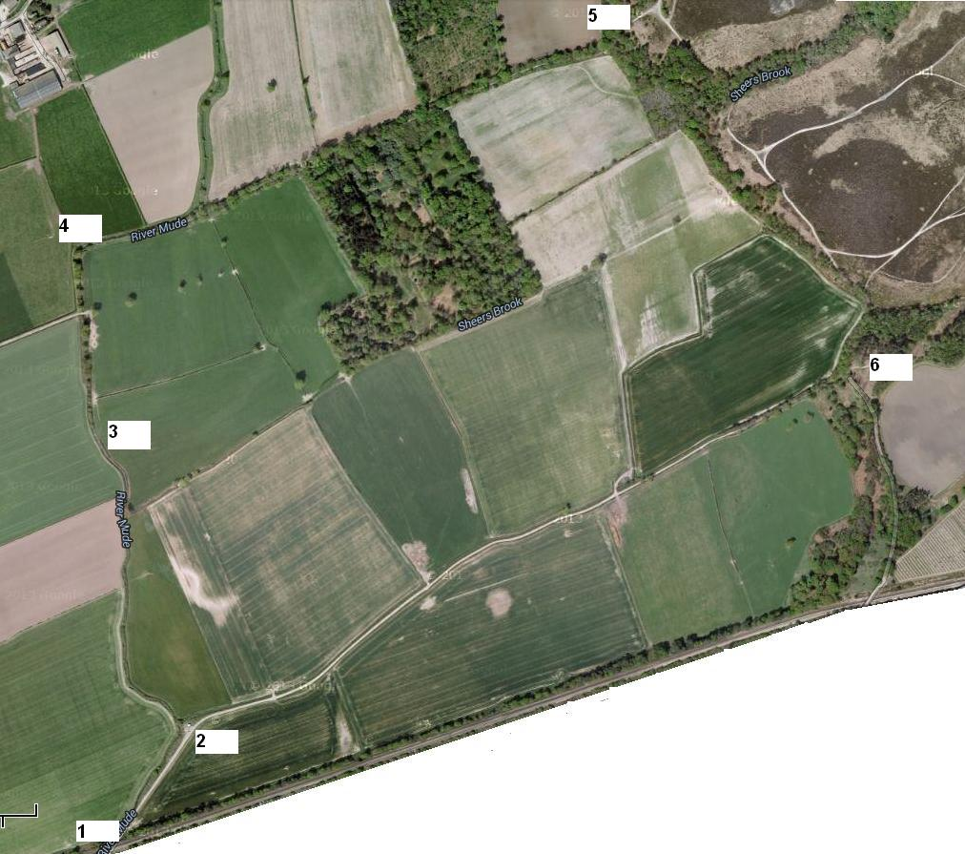
1. Start in the lane down the left-hand side of Sainsbury’s and run straight down the track
Go under the railway bridge (shown as 1 on the map).

2. When the track widens before the bend, look to your left for a concrete beam in the bushes – cross this

3. Stay to the right-hand side of the field and cross the stile halfway along

4. Run straight ahead until the track bends 90 degrees right – follow it round (do NOT climb over the stile on the bend)

5. After a long straight run, go through the gate, up a slope, and turn sharp right at the top. Follow the path, keeping right (ignore any paths to the left) and note there is a bridge to the right of the first stream crossing.

6. Keep right (ignore any paths to the left). Pass round the gate and take the right-hand path down a slope which eventually leads back to the start.

